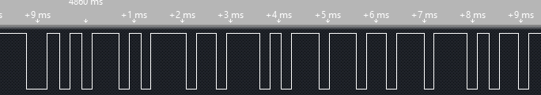

#1



#2



#3



#4

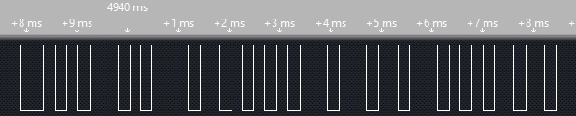

#5